Faculty of Information and Communication Technologies
HIT1301/HIT2080 Programming
Semester 2, 2013
Spike Outcome Report
Title: Custom Shape Drawing Spike
Author and ID: Davis Parker [490818x]
Overview: Learn how to declare procedures and call them later in other procedures.
Findings:
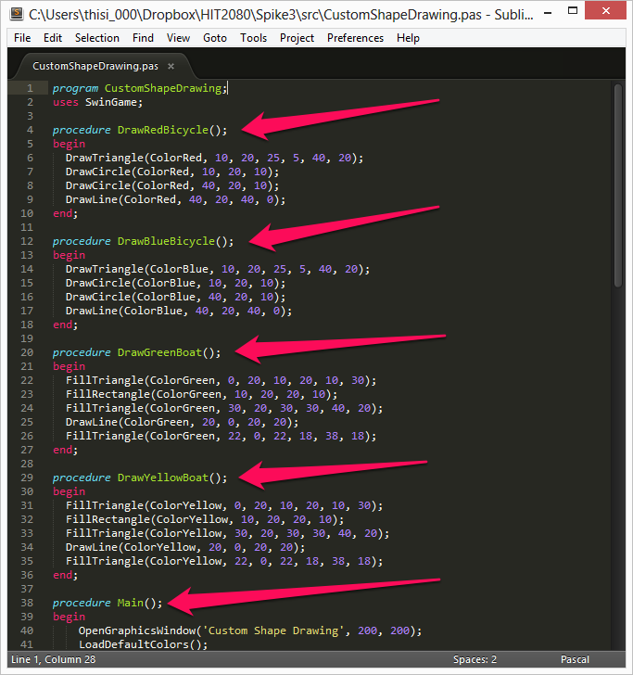
Procedure to draw a red bicycle using primitive shapes
Procedure to draw a Blue bicycle using primitive shapes
Procedure to draw a Green boat using primitive shapes
Procedure to draw a Yellow boat using primitive shapes
The main execution procedure.
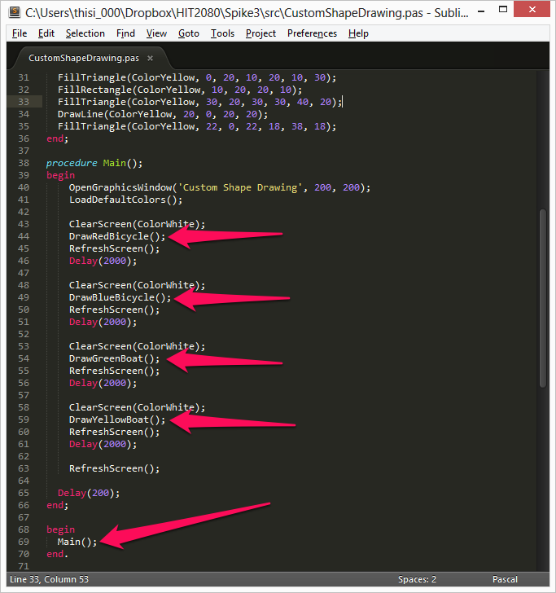
Call to DrawRedBicycle Procedure
Call to DrawRedBicycle Procedure
Call to DrawGreenBoat Procedure
Call to DrawYellowBoat Procedure
Call to main execution procedure
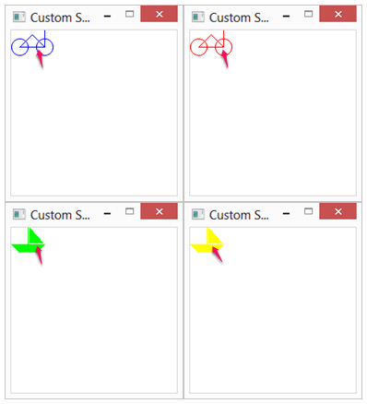
DrawBlueBicycle();
DrawRedBicycle();
DrawGreenBoat();
DrawYellowBoat();
Implications: In programming, a key component of being able to write code as fluently as a spoken language is using shortcuts and preventing overly verbose source code. Writing procedures, or functions, is an easy way to manage code effectively without rewriting chunks of code over and over again. In addition, procedures/functions allow programmers to create very structured code, which is easier to read later, as opposed to just dumping everything in the main constructor or execution loop.

